Contents

Object classification 2

Residual Networks (ResNet) – Deep Learning 2

ResNet50 Architecture 3

Transfer Learning – ResNet50 3

Approach_1 3

Model Key Attributes: 3

TensorFlow Keras Implementation: 4

Approach_2 Attributes: 5

Approach_3 Attributes: 6

Approach_4 Attributes: 7

Data augmentation sample: 11

Object Detection – Bounding box 11

Transfer Learning – ResNet50 11

Model Key Attributes: 11

Output sample 12

Points captured for future proceedings 12

Capstone project CV2

# Object classification

## Residual Networks (ResNet) – Deep Learning

After the first CNN-based architecture (AlexNet) that win the ImageNet 2012 competition, Every subsequent winning architecture uses more layers in a deep neural network to reduce the error rate. This works for less number of layers, but when we increase the number of layers, there is a common problem in deep learning associated with that called Vanishing/Exploding gradient. This causes the gradient to become 0 or too large. Thus when we increases number of layers, the training and test error rate also increases.

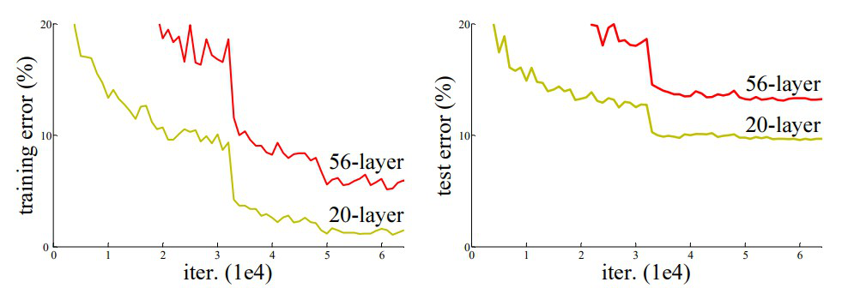

ResNet, which was proposed in 2015 by researchers at Microsoft Research introduced a new architecture called Residual Network.

**Residual Block:**  
In order to solve the problem of the vanishing/exploding gradient, this architecture introduced the concept called Residual Network. In this network we use a technique called ***skip connections*** . The skip connection skips training from a few layers and connects directly to the output.

ResNet, which was proposed in 2015 by researchers at Microsoft Research introduced a new architecture called Residual Network.

The advantage of adding this type of skip connection is because if any layer hurt the performance of architecture then it will be skipped by regularization.

There are many **variants** of **ResNet** architecture i.e. same concept but with a different number of layers. We have **ResNet**-18, **ResNet**-34, **ResNet**-50, **ResNet**-101, **ResNet**-110, **ResNet**-152, **ResNet**-164, **ResNet**-1202 etc.

## ResNet50 Architecture

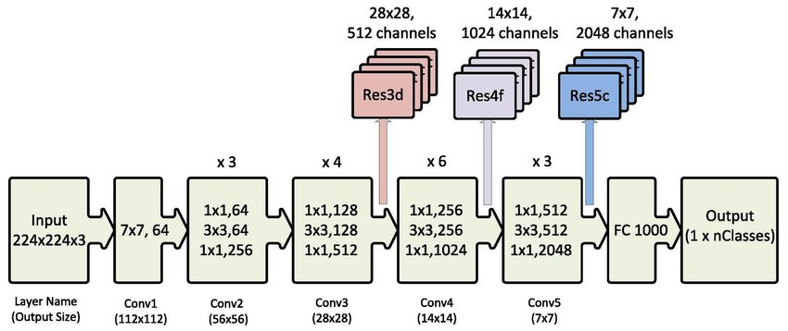

## Transfer Learning – ResNet50

## Approach_1

## Model Key Attributes:

* + ResNet50 is the Backbone architecture
  + Input Image size is 224*224*3
  + Augmentation on image dataset not applied
  + Optimizer = Adam
  + Loss for classification = ‘categorical_crossentropy’
  + Metrics for classification = ‘accuracy’
  + To implement Transfer learning, we would remove the last predicting layer of the pre-trained ResNet50 model and replace them with our own predicting layers.
  + Weights of ResNet50 pre-trained model is used as feature extractor
  + Weights of the pre-trained model are frozen and are not updated during the training
  + We do not want to load the last fully connected layers which act as the classifier. We accomplish that by using “include_top=False”. We do this so that we can add our own fully connected layers on top of the ResNet50 model for our task-specific classification.
  + We freeze the weights of the model by setting trainable as “False”. This stops any updates to the pre-trained weights during training We do not want to train ResNet layers as we want to leverage the knowledge learned by the deep neural network trained from the previous data set which in our case is “imagenet”
  + Adding our own layers and the final classifier using softmax activation function.

## TensorFlow Keras Implementation:

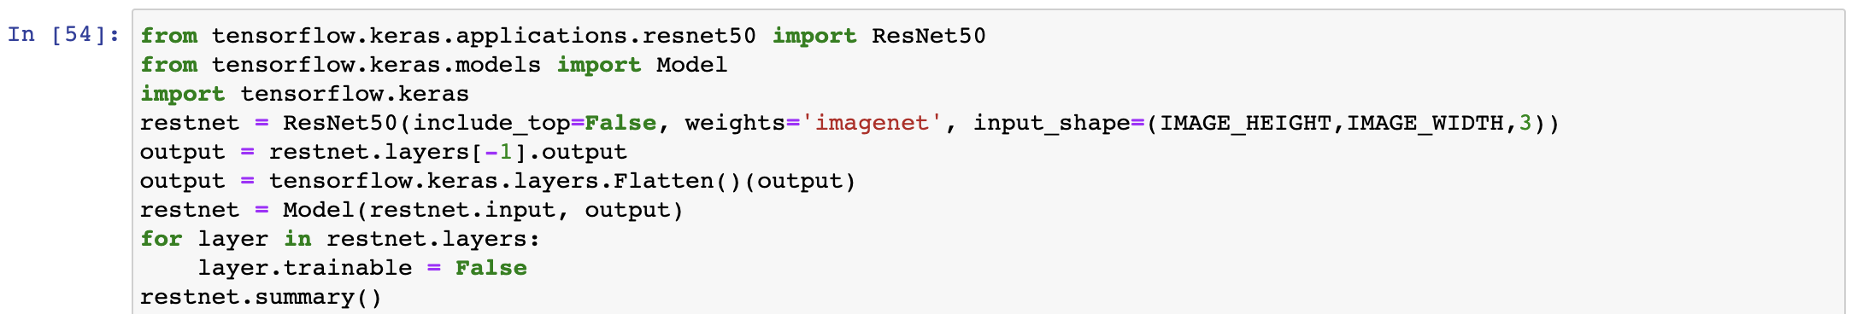

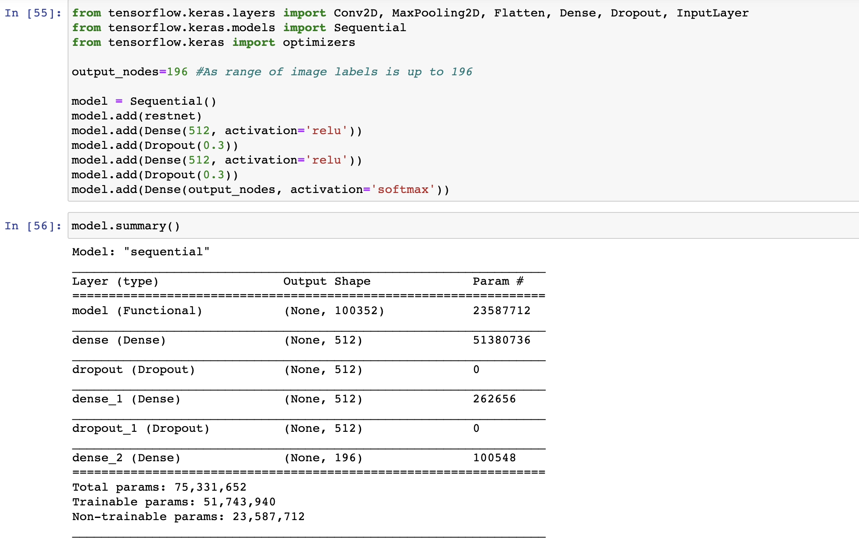

* + Model performance very much poor

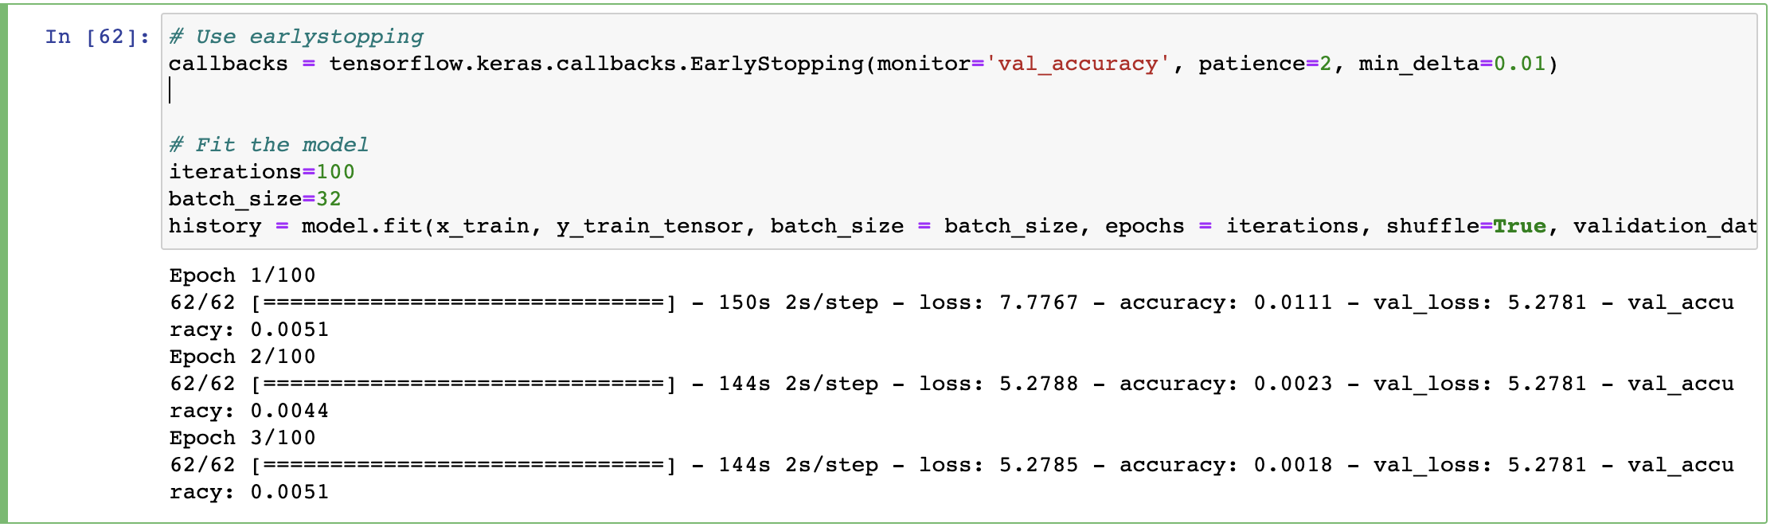



* + Data Preparation

Data frame creation - merging train / test images and its annotations respectively.

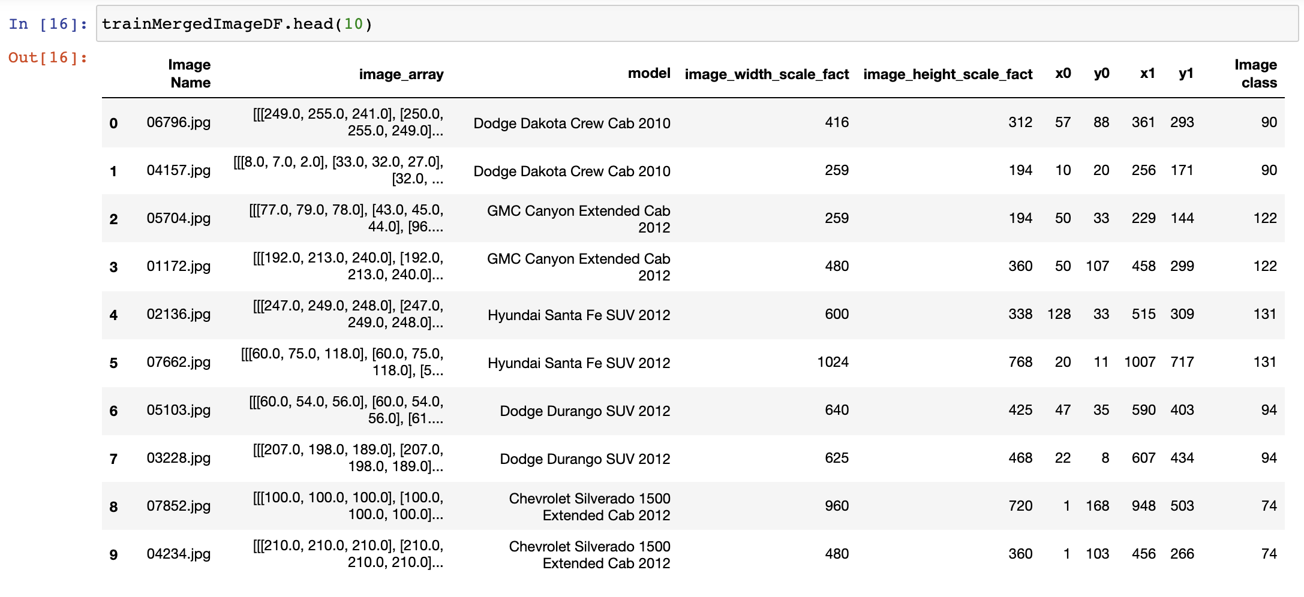

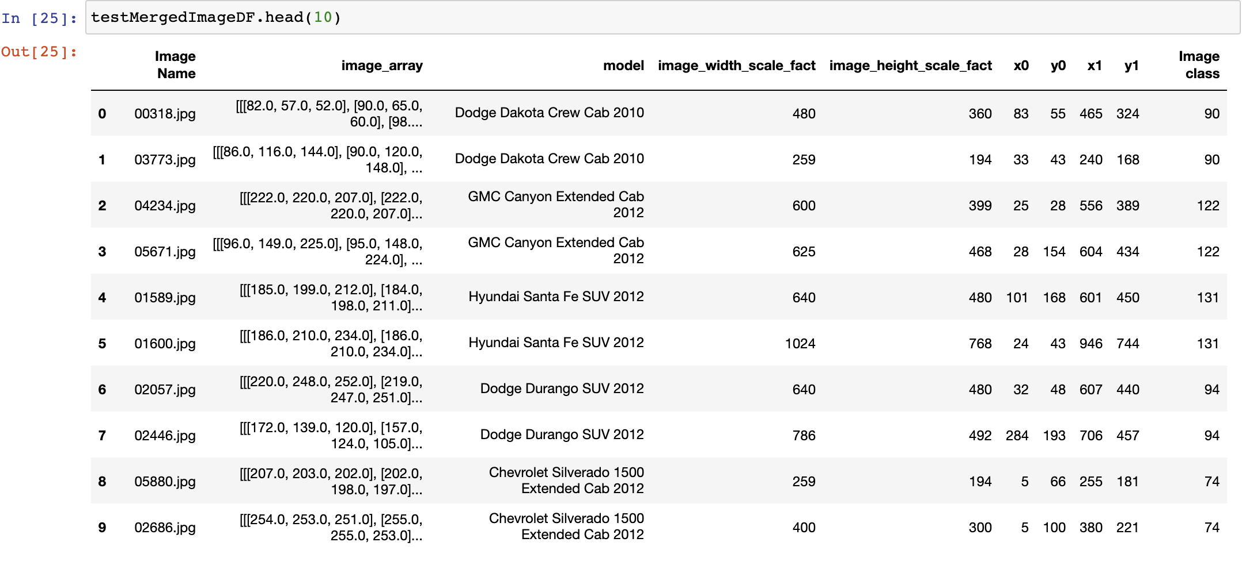

## Approach_2 Attributes:

* + Unfreezing a few of the last convolution blocks while keeping the first early conv blocks frozen. This will help us to learn very generic features using early layers. Higher layers of pre-trained models will be trainable or fine-tuned.

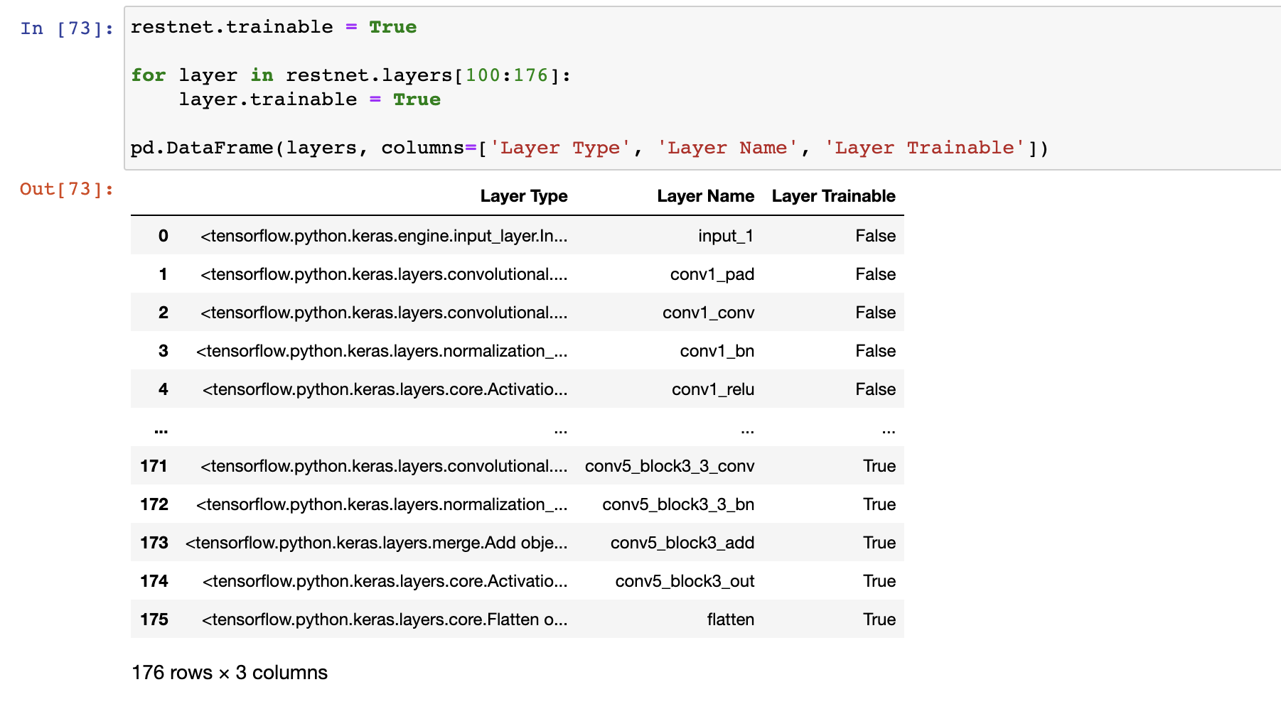

* Model performance not – remarkable

62/62 [==============================] - 148s 2s/step - loss: 5.2785 - accuracy: 0.0044 - val_loss: 5.2780 - val_accuracy: 0.0095

## Approach_3 Attributes:

* + Image data augmentation implementing TensorFlow ImageDataGenerator.

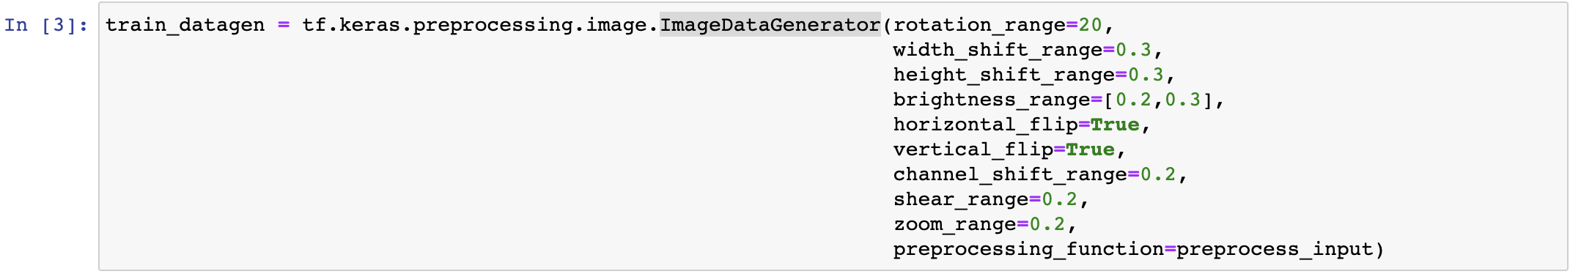

* + ResNet50 with pretrained weights
  + Normalized test images treated as validation dataset
  + Accuracy improved significantly [23%]

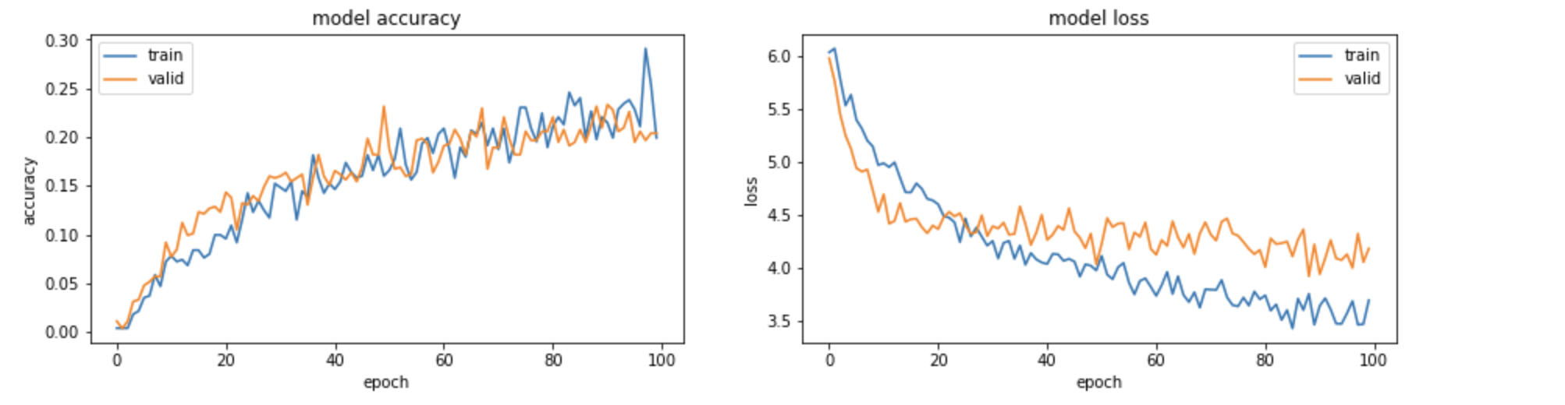

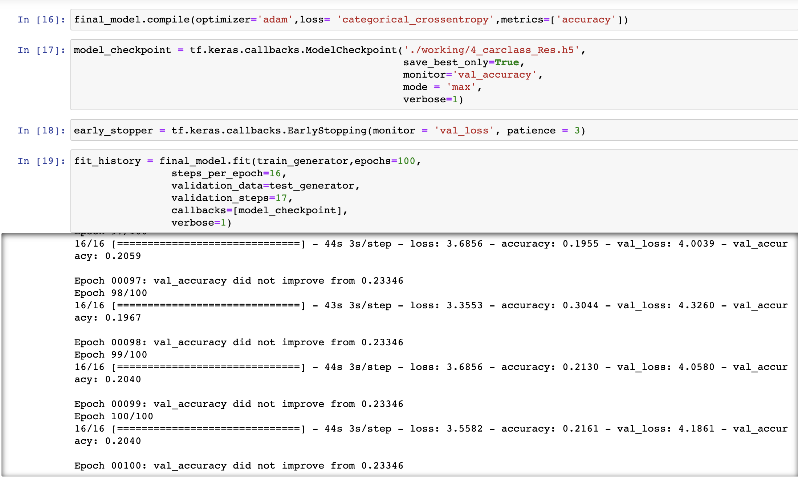



## Approach_4 Attributes:

* + Validation dataset created from test images.

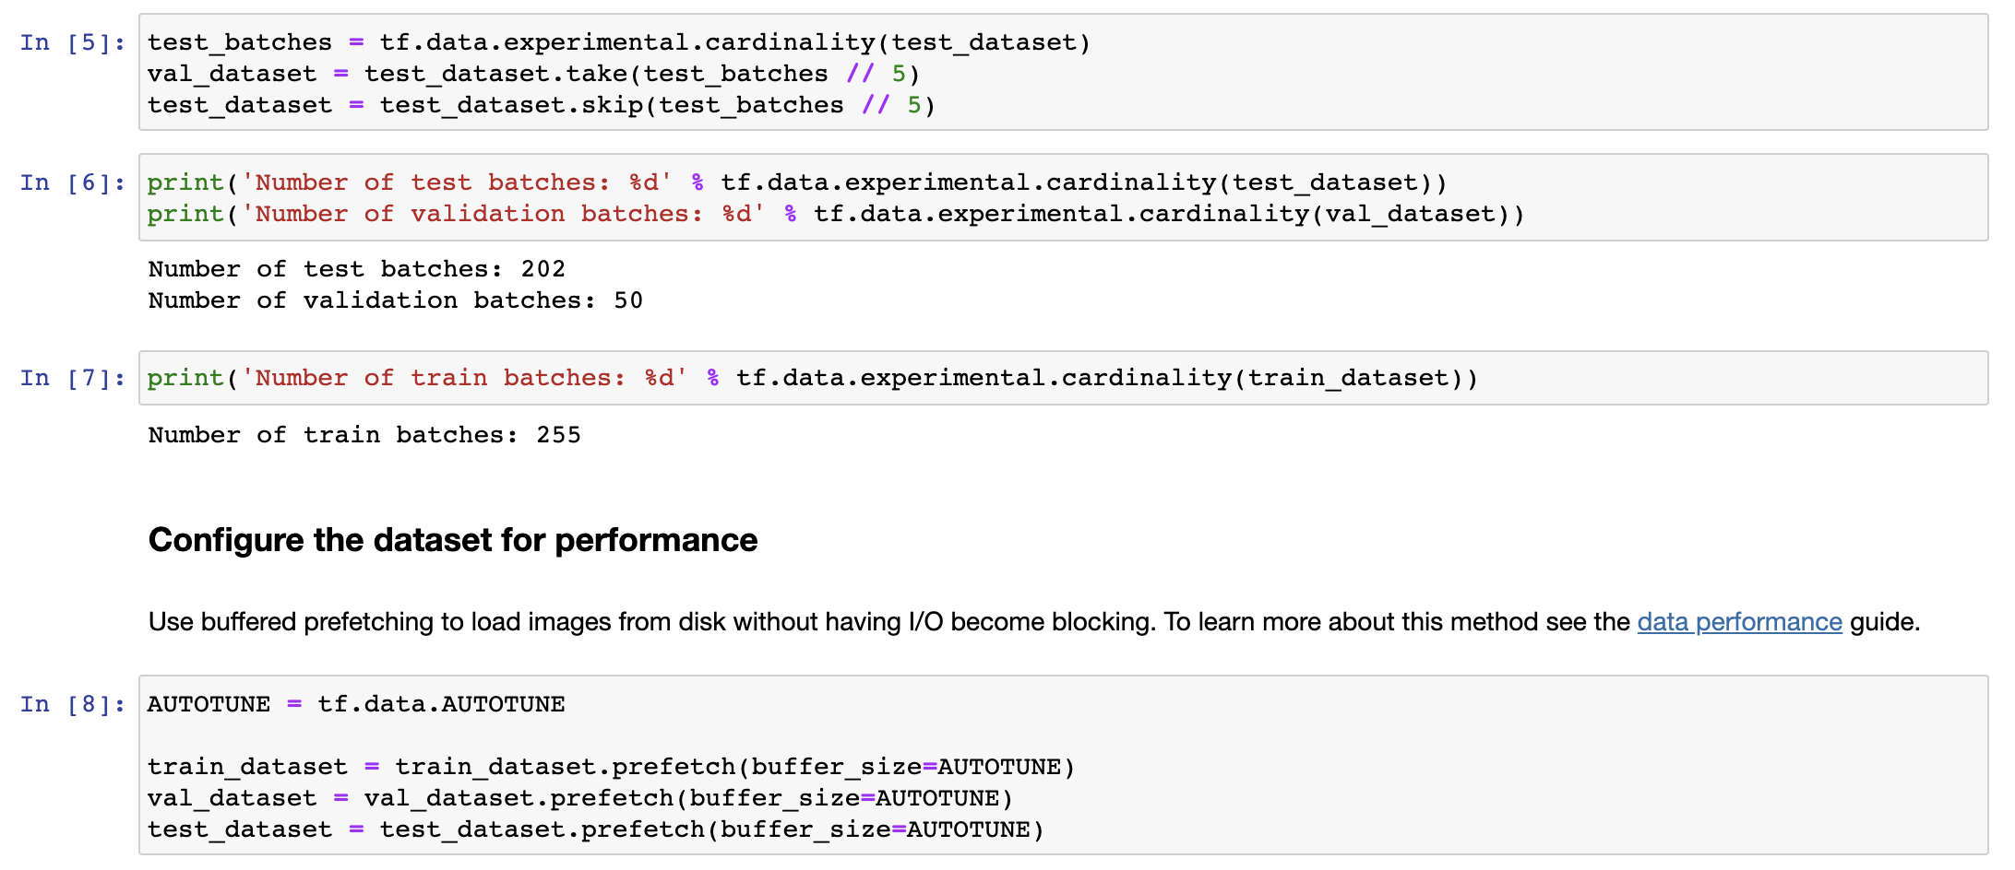

* + Added data augmentation layer

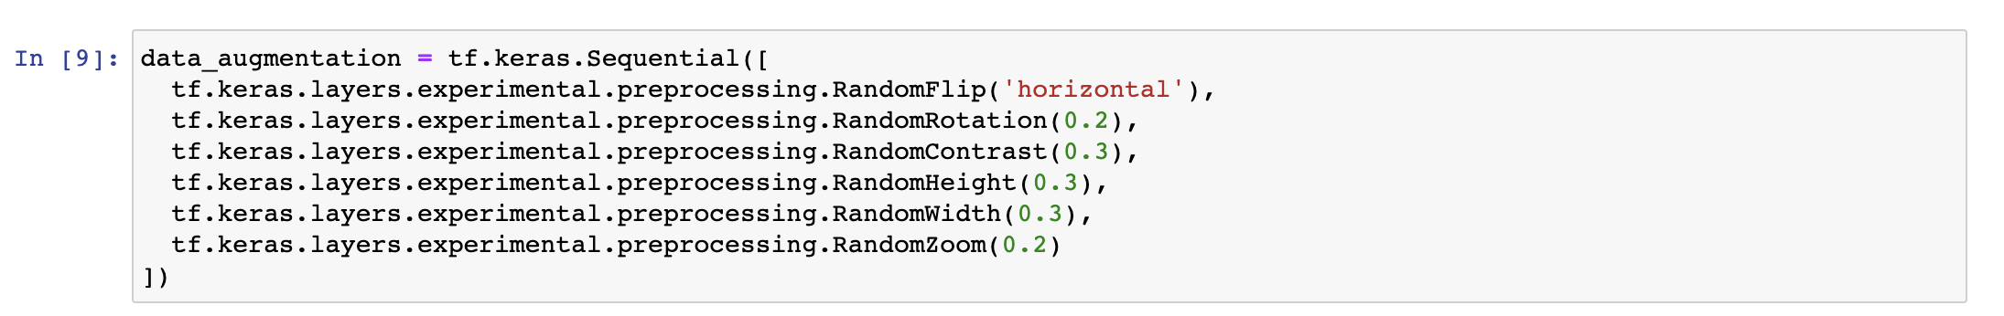

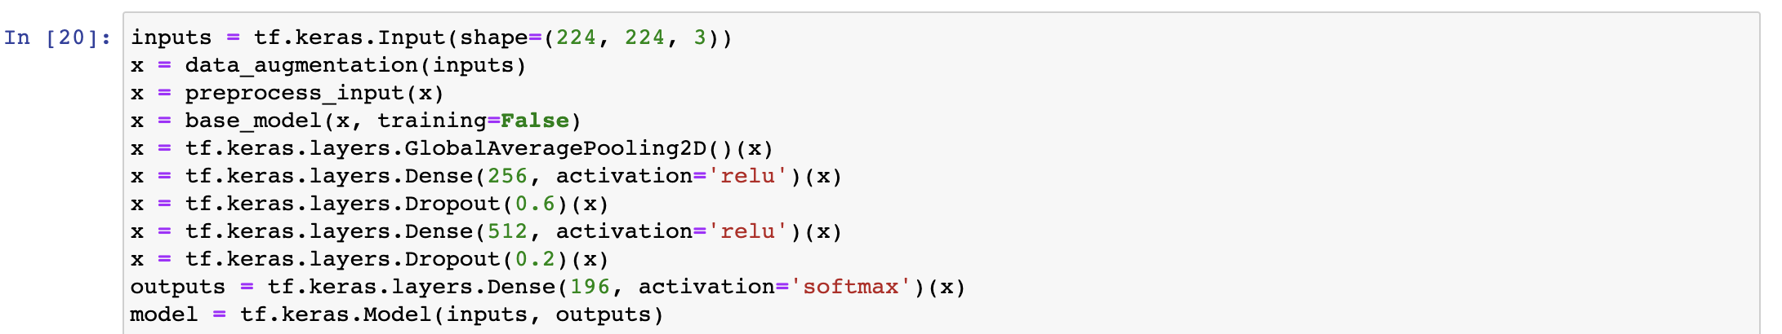

* + Without unfreezing any layer for training accuracy reached 25%

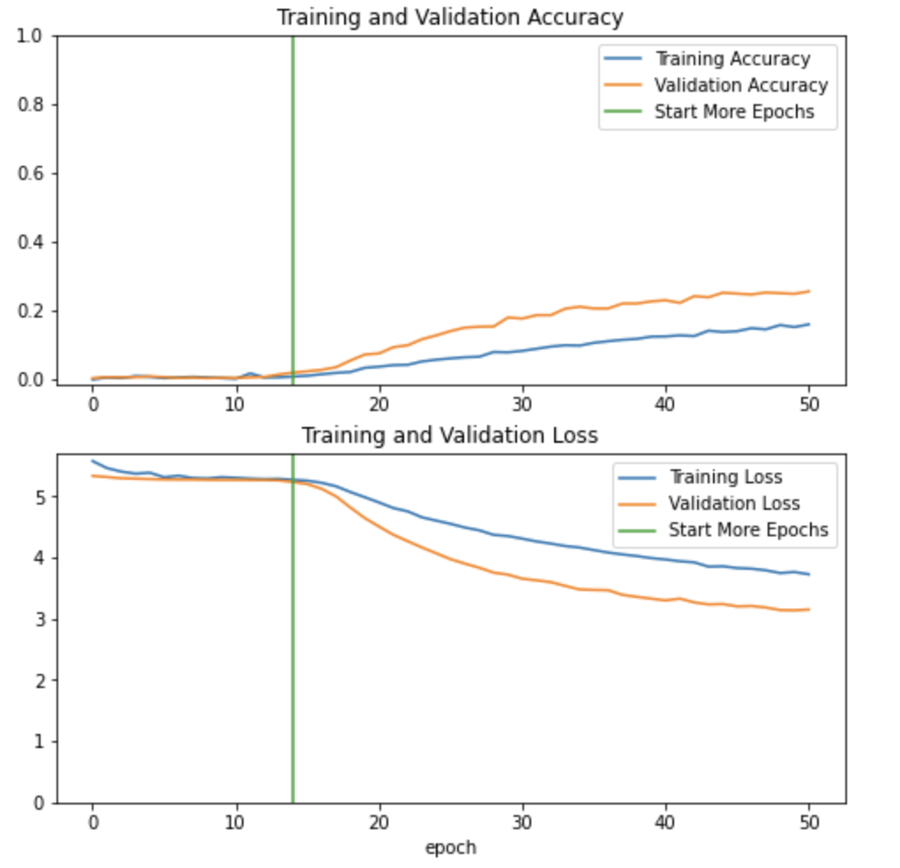

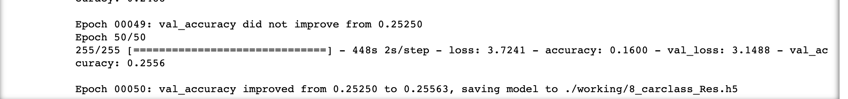



* + Unfreezing the base_model and set the bottom layers to be un-trainable.
  + As we are training a much larger model and want to readapt the pretrained weights, it is important to use a lower learning rate at this stage. Otherwise, model could overfit very quickly.

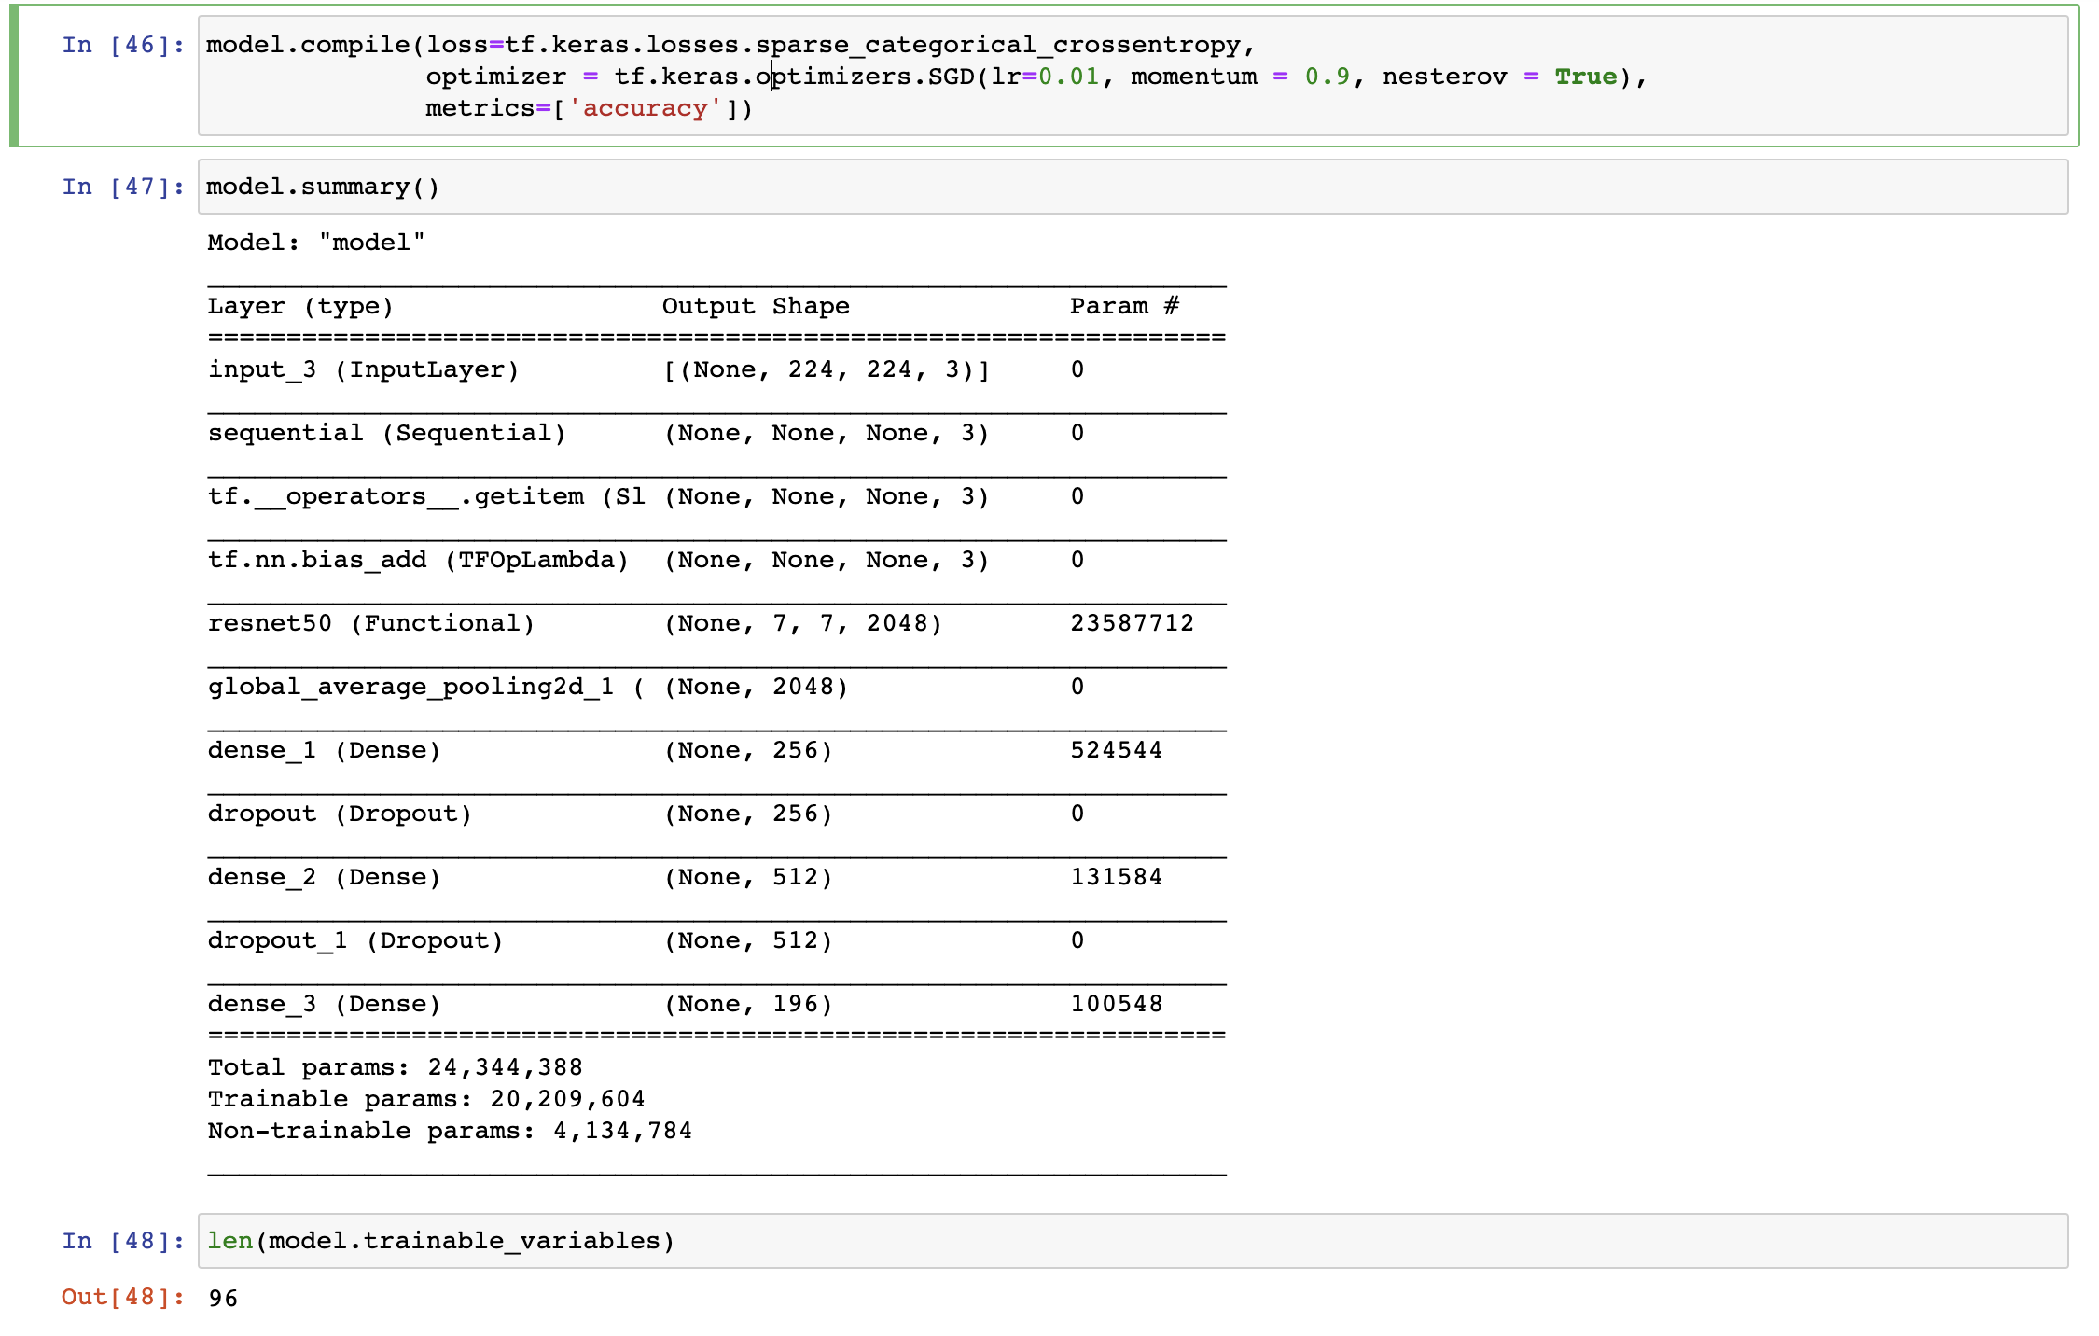



* Hyperparameter momentum accelerates gradient descent in the relevant direction and dampens oscillations.
* Accuracy reached ~40%

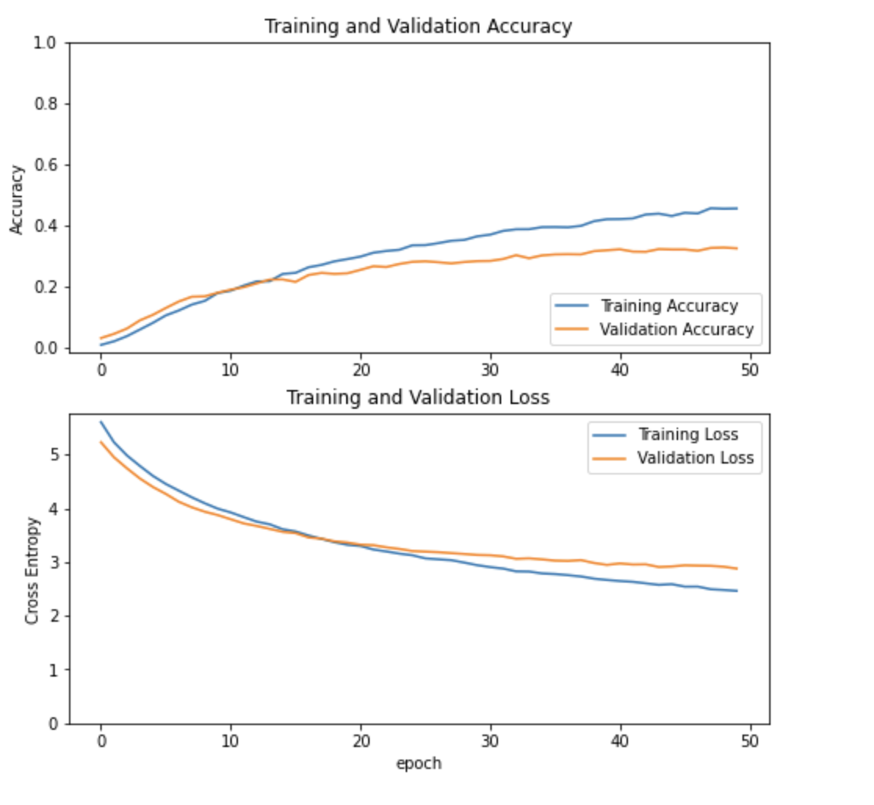

## Data augmentation sample:

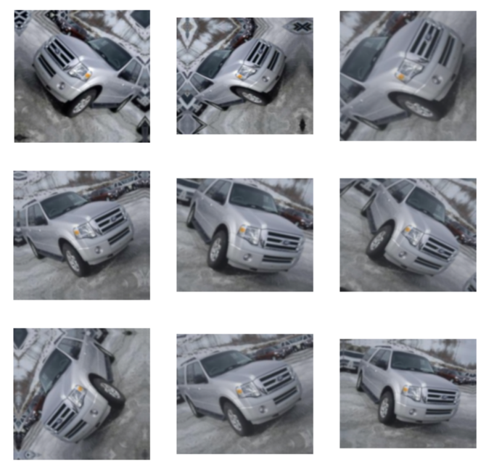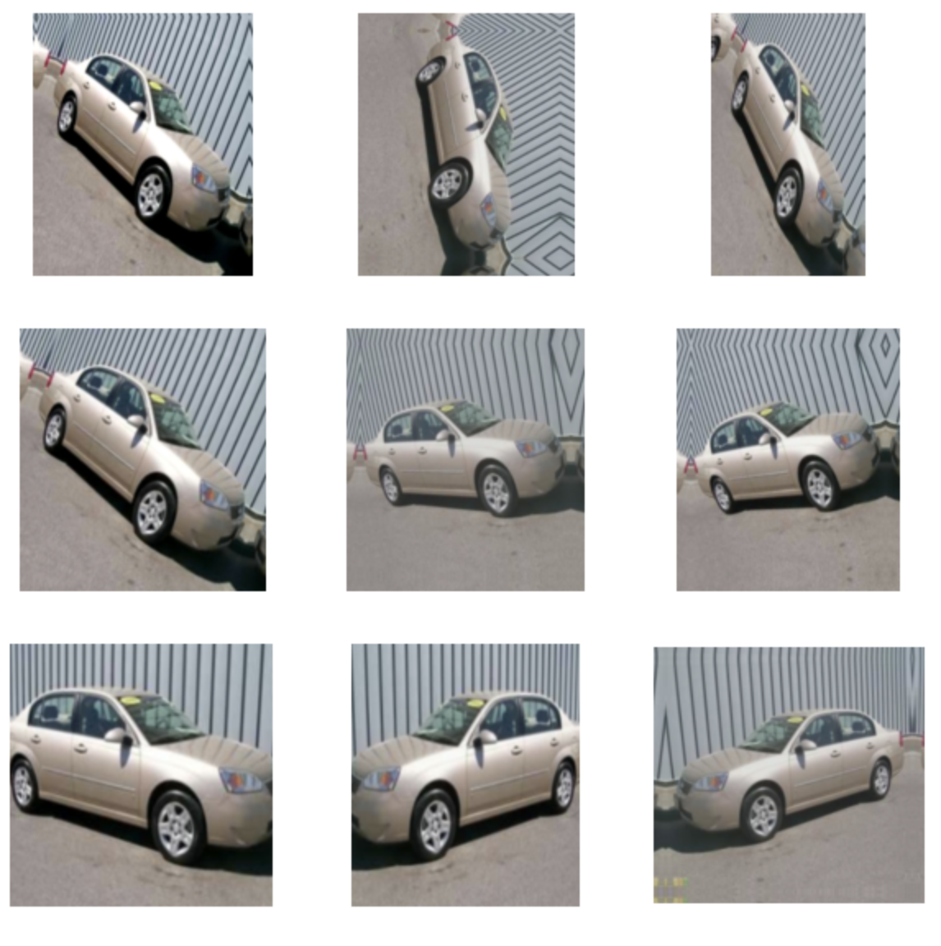

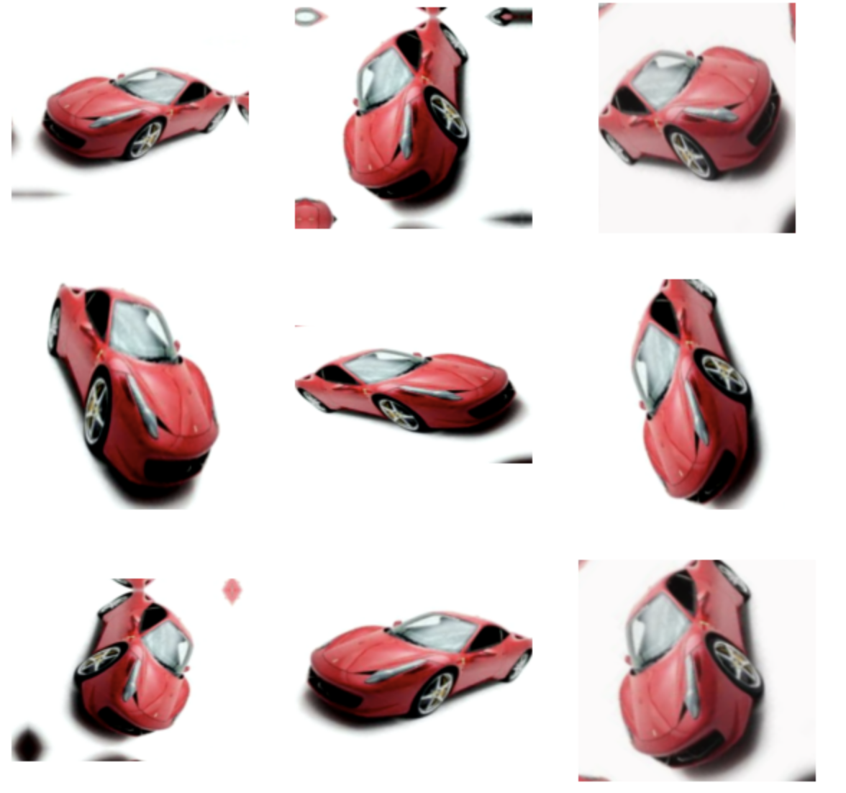

# Object Detection – Bounding box

## Transfer Learning – ResNet50

## Model Key Attributes:

* + ResNet50 is the Backbone architecture
  + Input Image size is 224*224*3
  + Optimizer = Adam
  + Loss for bounding box coordinates =‘mse’
  + Metrics for object detection = ‘‘IoU’ [Intersection over Union]

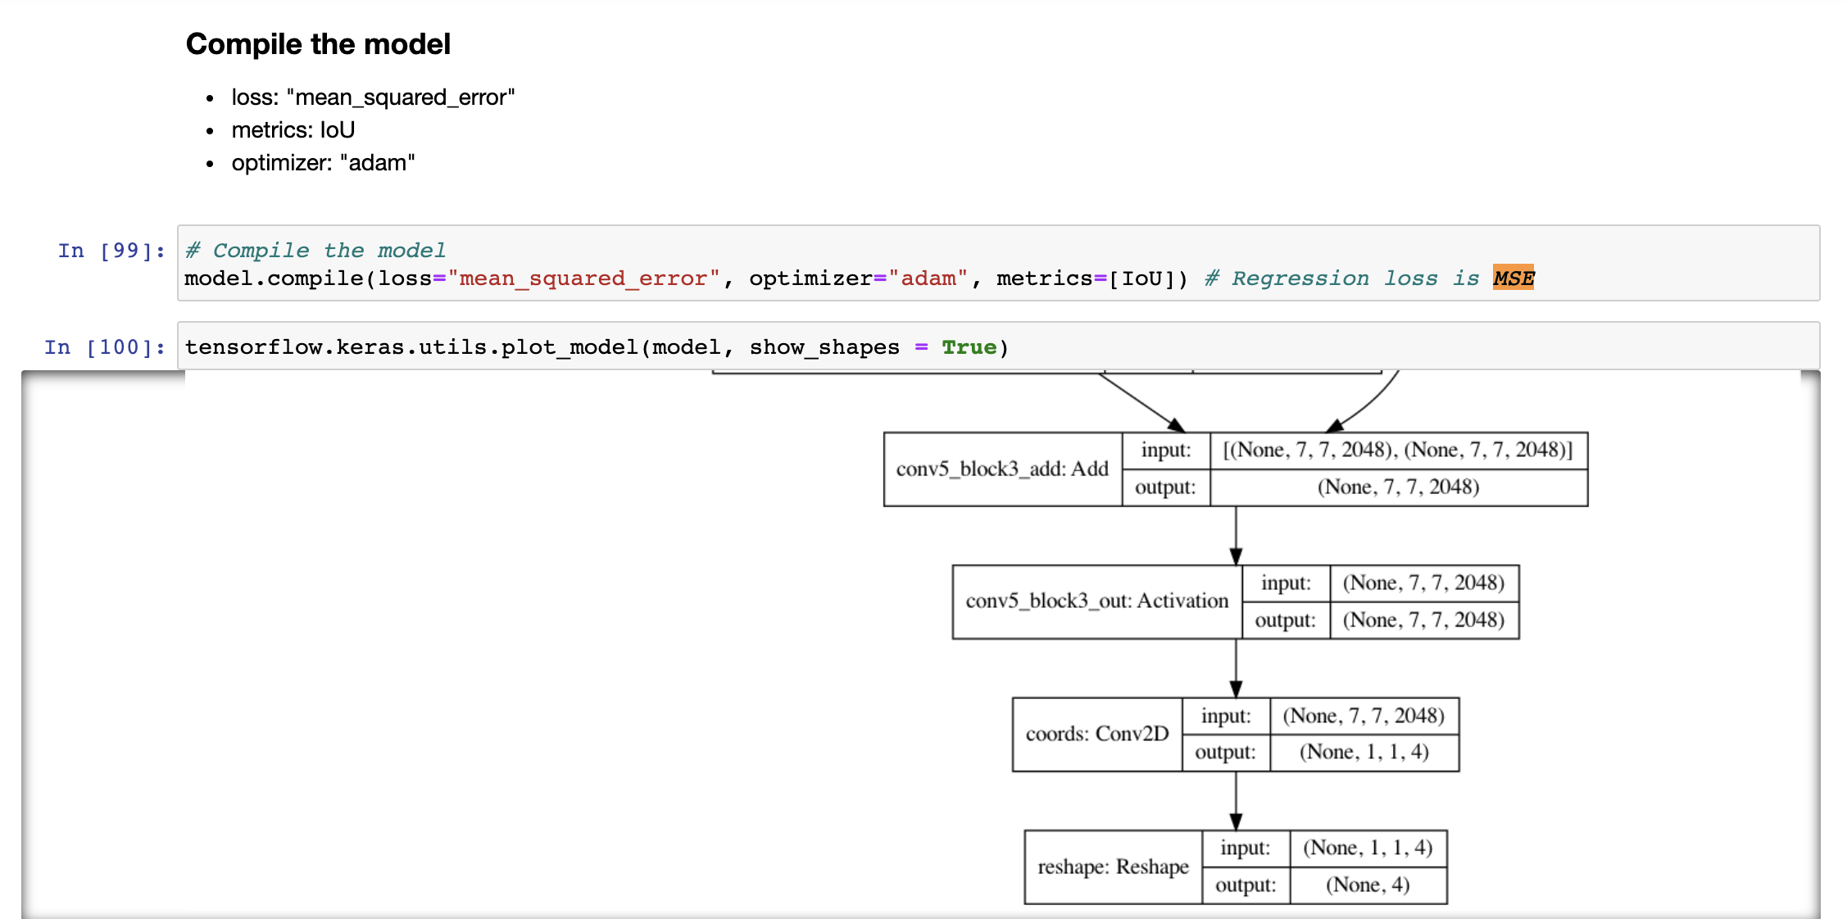

* Accuracy ~77%

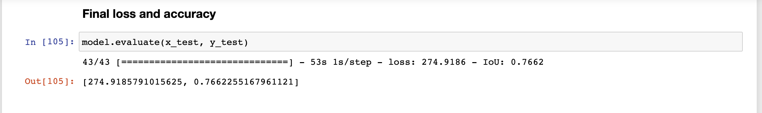

## Output sample

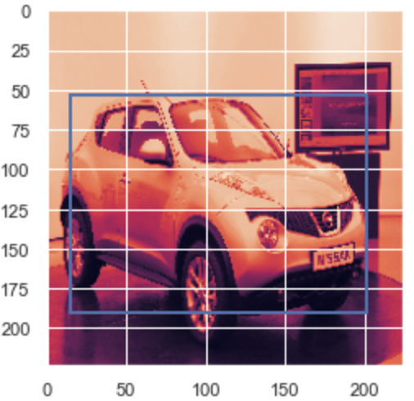 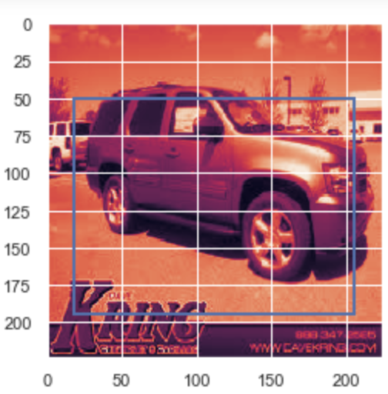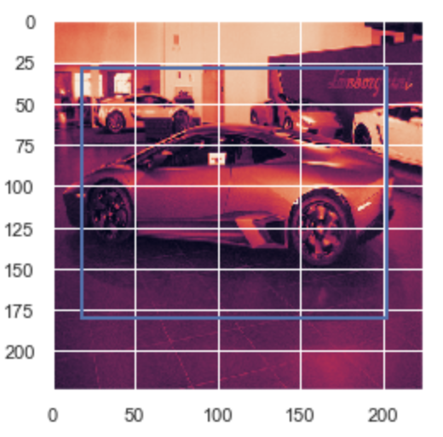

# Points captured for future proceedings

* Tried to apply transfer learning InceptionV3 base model, used tensor flow implementation. Even after unfreezing layer and train the weights accuracy much poorer than ResNet50 so further exploration would be around ResNet only

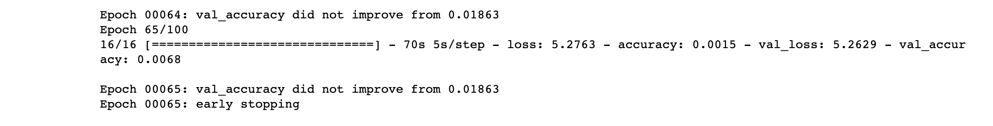



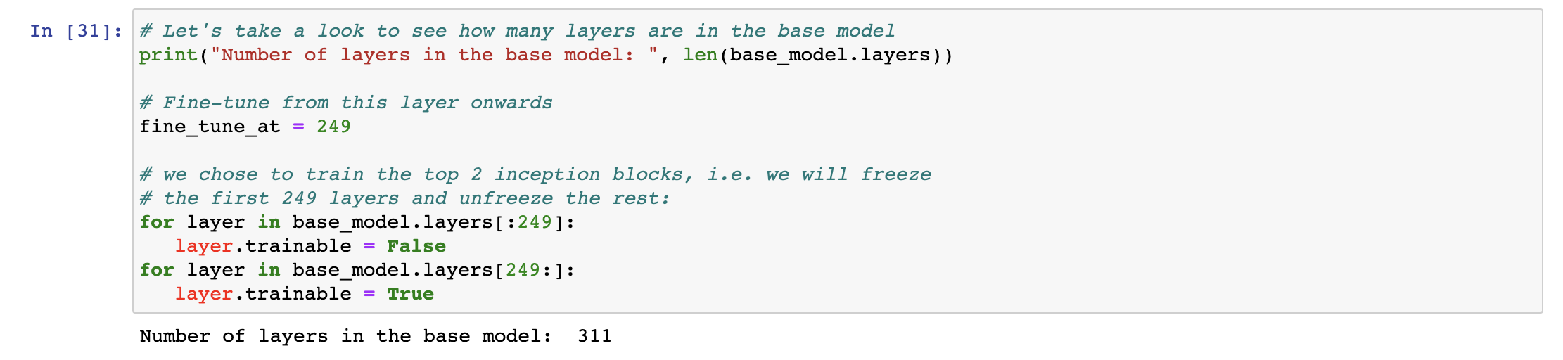

* Started exploring pytorch ResNet34 implementation. Better accuracy observed. Valid / test dataset center cropped. Building understanding on pytorch APIs. CUDA / CPU device type need to be handled thoroughly to load / save parameters / data / weights / model accordingly.

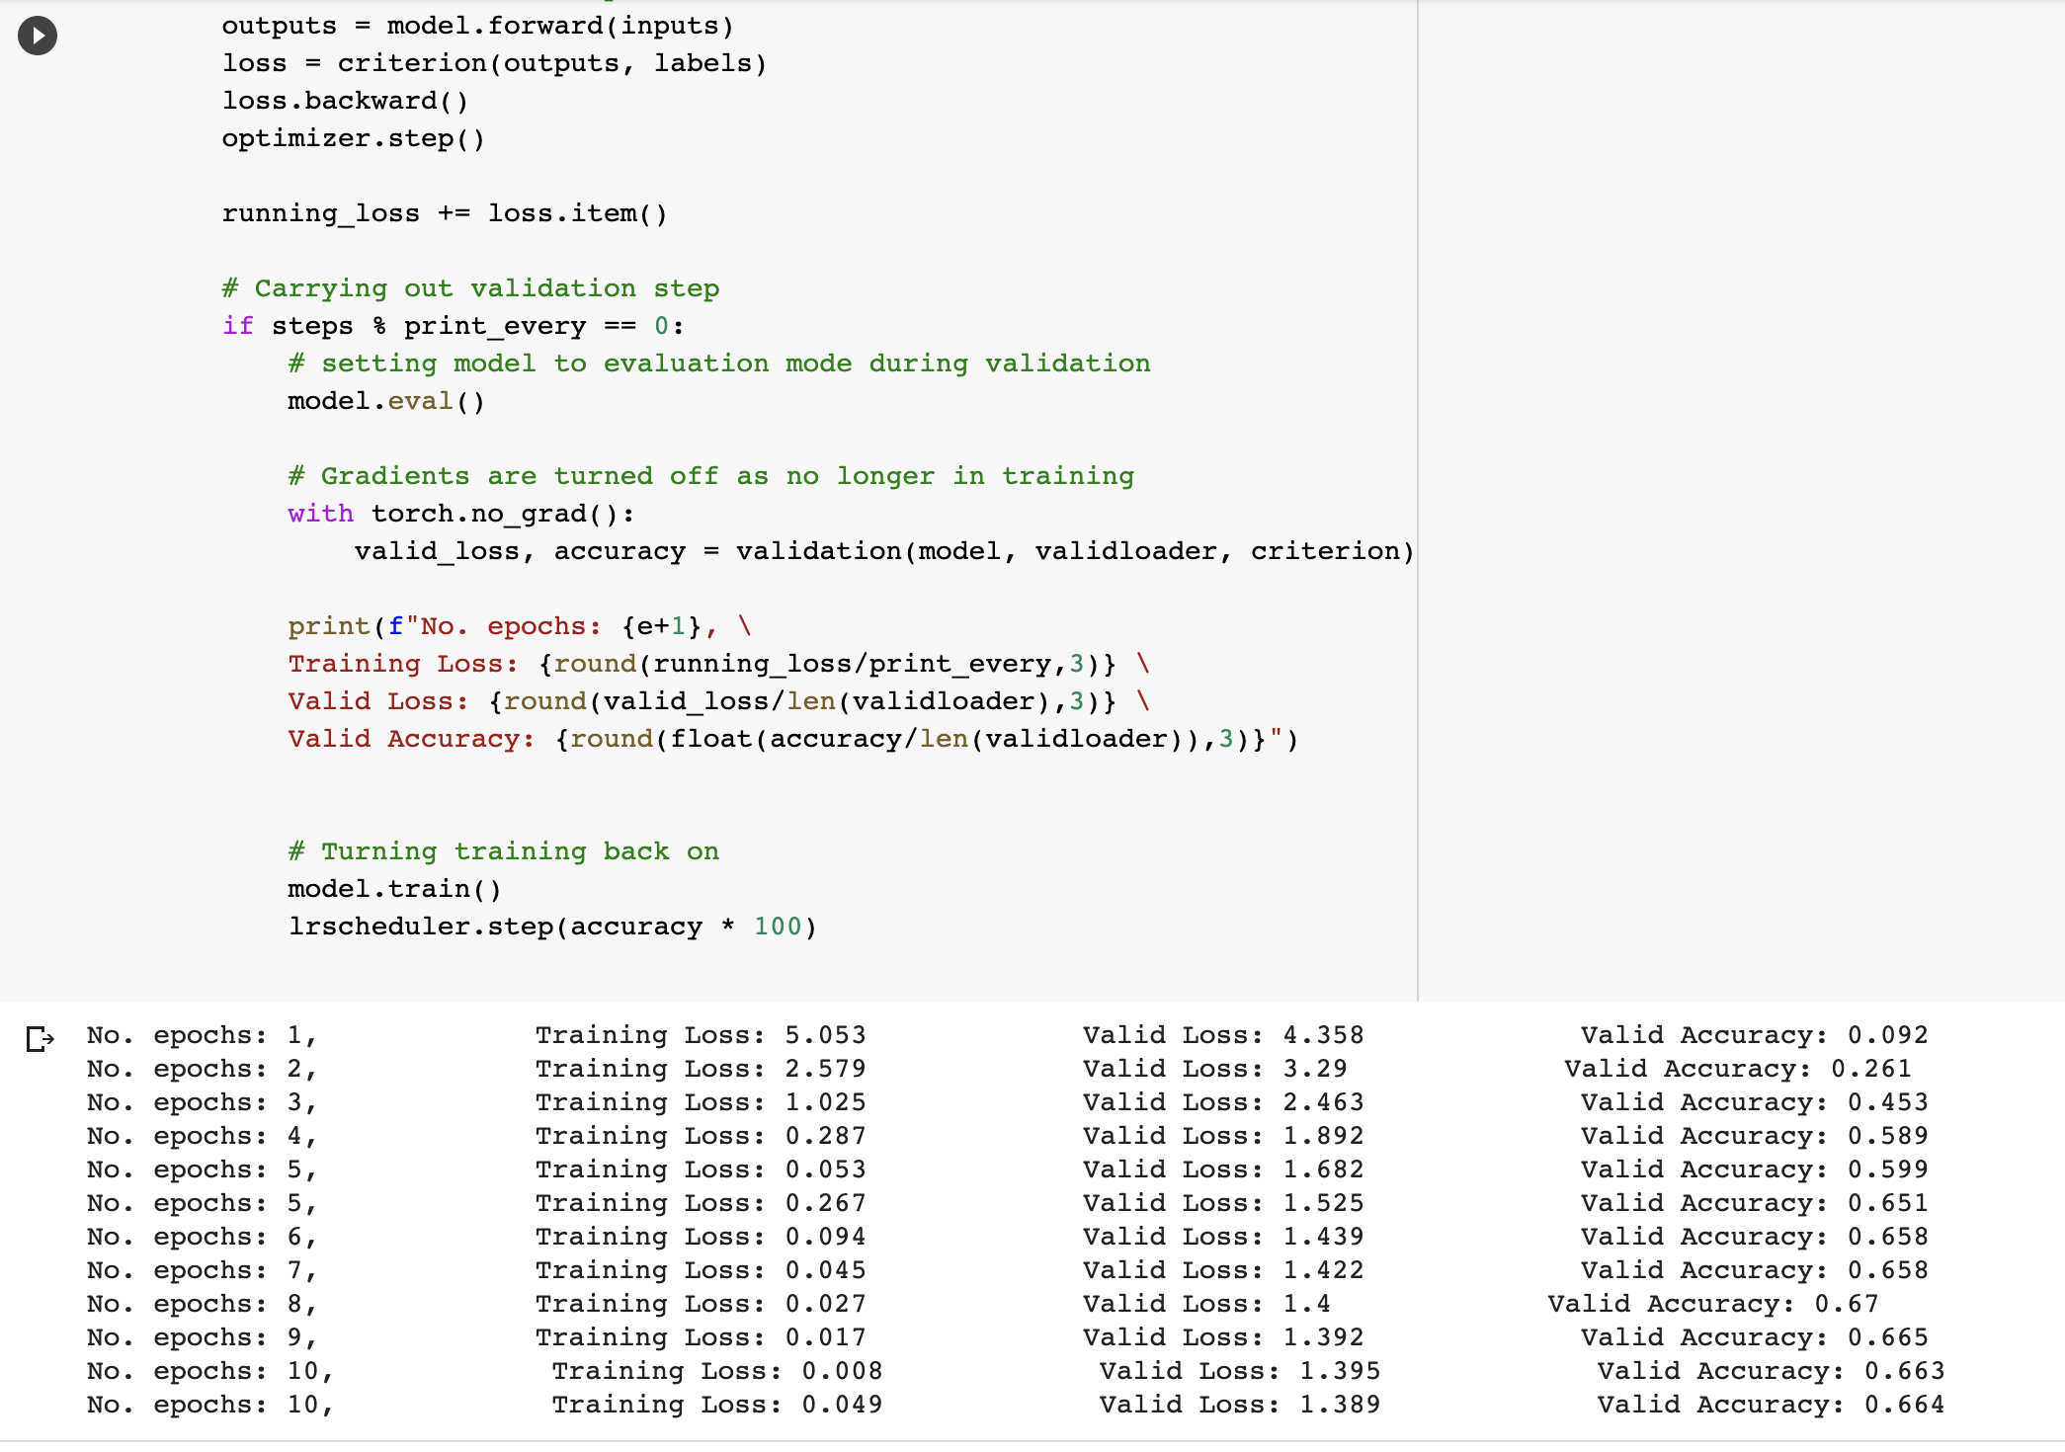



* Cross validation among datasets to close the gap between train and val accuracy.
* Hyperparameter Tuning - Learning rate, Momentum, Batch Size, Epochs, train / val / test percentage
* Playing around augmentation to avoid overfitting / high bias concern
* Cloud based deployment pipeline